**ANAYLSIS IN SQL [STEP – 2]**

* **Measures of central tendancy :**

1. **Mean:**





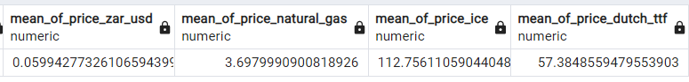

1. A screenshot of a computer

   AI-generated content may be incorrect.A screenshot of a computer

   AI-generated content may be incorrect.A screenshot of a computer

   AI-generated content may be incorrect.A screenshot of a cell phone

   AI-generated content may be incorrect.A screenshot of a computer

   AI-generated content may be incorrect.A screen shot of a computer

   AI-generated content may be incorrect.A screenshot of a computer

   AI-generated content may be incorrect.A screenshot of a computer

   AI-generated content may be incorrect.**Mode :**

1. **A screenshot of a computer

   AI-generated content may be incorrect.A screenshot of a computer

   AI-generated content may be incorrect.A screenshot of a computer

   AI-generated content may be incorrect.A screenshot of a computer

   AI-generated content may be incorrect.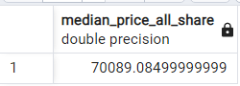A screenshot of a computer

   AI-generated content may be incorrect.A screenshot of a computer

   AI-generated content may be incorrect.A screenshot of a computer

   AI-generated content may be incorrect.A screenshot of a computer

   AI-generated content may be incorrect.MEDIAN:**

* **Measures of dispersion (variance, standard deviation):**

**(Varience,Standard deviation,Range)**

